Temporal Graph Networks for Fraud Detection
AWS Demo Architecture — One-Page Brief

Objective
Deploy a working demonstration of a Heterogeneous Temporal Graph Network (TGN) for real-time financial fraud detection on AWS. The demo will ingest synthetic transaction streams, score them through a trained TGN model, and visualise risk decisions in real-time — showing the value of graph-based approaches over traditional rule engines.

Architecture Overview
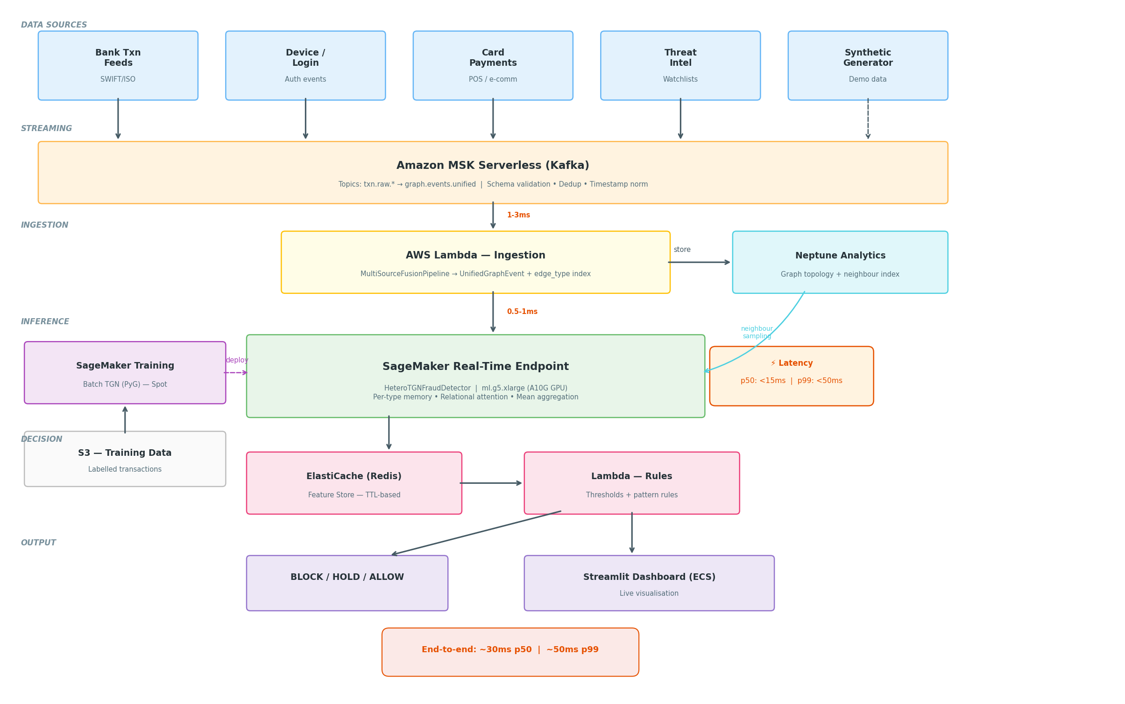
Layer | AWS Service | Purpose | Why This Choice
Streaming | Amazon MSK Serverless | Kafka topics for raw events | Serverless = no cluster ops, pay-per-use
Ingestion | AWS Lambda | Transform events to unified schema | Auto-scales, cheap, easy to demo
Graph Store | Neptune Analytics | Graph topology + neighbour index | Purpose-built, openCypher queries
Training | SageMaker Training | Batch TGN model training (PyG) | Managed GPU, spot pricing
Inference | SageMaker Endpoint | Real-time TGN scoring | ml.g5.xlarge (A10G) for <15ms p50
Feature Store | ElastiCache (Redis) | Risk scores + pattern profiles | Sub-ms reads, TTL-based expiry
Rules Engine | Lambda | Threshold evaluation + actions | Stateless, event-driven
Dashboard | Streamlit on ECS Fargate | Live visualisation + graph explorer | Rapid development, visually rich
Data Gen | Lambda (scheduled) | Synthetic fraud scenario generator | Controlled demo narratives

Data Flow
Synthetic Generator → MSK (Kafka) → Lambda Ingestion → Unified Schema → SageMaker Endpoint (TGN inference) → Redis (feature store) → Rules Lambda → Dashboard
Latency target: p50 < 15ms, p99 < 50ms (GPU batched inference). End-to-end event-to-decision: ~30ms p50.

Demo Scenarios
The synthetic data generator produces controlled fraud patterns to showcase TGN capabilities versus static rules:
- Structuring: 8 transfers of £9,500 in 1 hour (below £10K SAR threshold) — TGN detects via mean-aggregated burst signal; rules miss it.
- Account Takeover: New device login → rapid transfers to unfamiliar destinations — TGN correlates cross-type signals (login + transfer).
- Mule Network: Ring of 6 accounts passing money in a circle — TGN detects via neighbourhood topology; rules see isolated legitimate transfers.
- False Positive Reduction: Payroll run (50 legitimate payments from one account) — TGN recognises learned pattern; rules would flag velocity.

Key Technical Differentiators
- Heterogeneous Graph: Per-type memory banks (accounts, devices, merchants, threat indicators) with independent evolution.
- Typed Message Functions: Learned MLPs per edge type — transfers, logins, and alerts produce structurally different signals.
- Relational Attention: Per-edge-type Key/Value projections so the model attends differently to transfer neighbours vs device-sharing neighbours.
- Mean Aggregation: Preserves full burst context (all messages within a batch) rather than discarding all but the last.
- Conformal Prediction: Uncertainty bounds on every risk score — tells you "how sure are we?" not just "is this risky?"
- Transfer Learning: Institution-agnostic feature encoding (percentiles, cyclical time) enables fine-tuning across banks.

Implementation Timeline
Week | Deliverable | AWS Services Used
1 | Synthetic data generator + SageMaker notebook (train model, prove it works) | SageMaker Studio, S3
2 | Model packaging + SageMaker real-time endpoint + Lambda integration | SageMaker Endpoint, Lambda, ECR
3 | MSK streaming + Redis feature store + Streamlit dashboard | MSK Serverless, ElastiCache, ECS Fargate
4 | Neptune graph explorer + demo polish + rehearsal | Neptune Analytics, CloudWatch

Cost Estimate (Demo Environment)
Running 8 hours/day, Tier 2 (customer-facing demo):
Service | Config | Monthly
SageMaker Endpoint | ml.g5.xlarge, 8hr/day | £280
MSK Serverless | ~1GB throughput/day | £15
ElastiCache | r6g.large | £90
Lambda | ~100K invocations/day | £5
Neptune Analytics | 4 vCPU | £180
ECS Fargate (Streamlit) | 0.5 vCPU / 1GB | £20
Total |  | ~£590/month
Cost reduction: Scale SageMaker endpoint to 0 when idle + scheduled MSK = ~60% savings for intermittent demos.

Prerequisites
- AWS Account: With SageMaker, MSK, Neptune, ElastiCache, Lambda, ECS access
- GPU Quota: ml.g5.xlarge for SageMaker endpoint (request via Service Quotas if needed)
- Framework: PyTorch 2.x + PyTorch Geometric (pre-built in SageMaker PyTorch container)
- Data: No real customer data needed — synthetic generator creates realistic patterns
Reference: tgn_fraud_detection_guide_v2.md — Full technical implementation guide with code.

